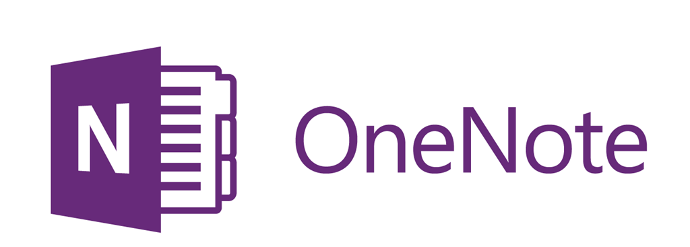

For course information and notes
For course information and notes
Access your
‘English’ folder in your Google Drive.
(I have shared it with you.)
In your ‘English’ folder, create
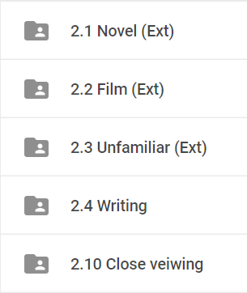
folders for standards

Put your work in here
(Yes, in the correct folders!)
To Create a Folder
- Open your English folder.
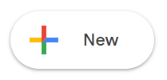
- Hit

- Choose ‘Folder’

- Name your folder!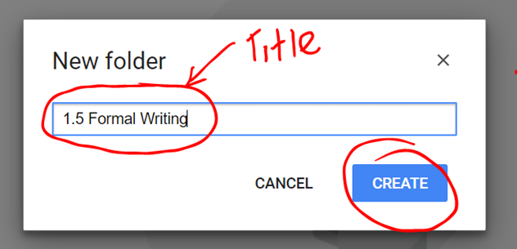
To Create a Doc
- Open your English folder.
- Hit

- Choose ‘Google Docs’, or whatever you need.
Name Your Documents!
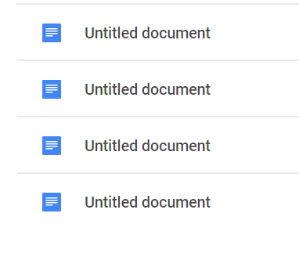
Click here. Type title as well as your name.
Ready for feedback?
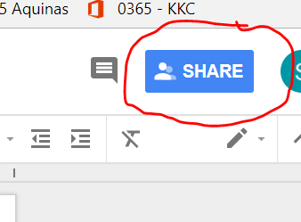
Hit SHARE

I get an email to say you’re ready and waiting!
Submitting FINAL?

- Hit SHARE.
- Add a quick note to say it’s your final.
- Look out for my reply to say I have received it!!
Note, from here I will make a copy and save it in my own folder to mark from there. I will later share that marked copy with you.
Final work is
marked and returned

Find it in your ‘English Work’ folder as a copy of your original document.

To move a document
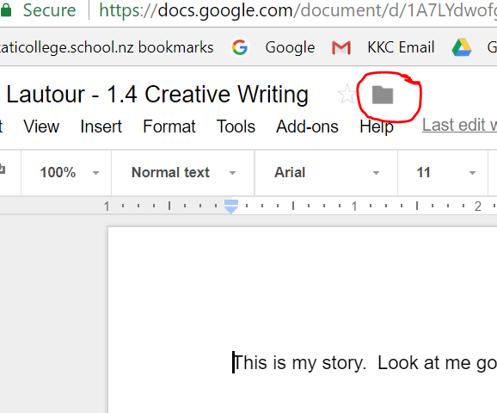
Click on wee folder
Choose destination
To make a new folder
Finally, click
For more options

